

Draw It or Lose It – Web-Based Game Application

CS 230 Project Software Design Proposal
Version 1.0

Table of Contents

CS 230 Project Software Design Template 1
Table of Contents 2
Document Revision History 2
Executive Summary 3
Requirements 3
Design Constraints 3
System Architecture View 3
Domain Model 3
Evaluation 4
Recommendations 5

Document Revision History

Version | Date | Author | Comments
1.0 | 06/25/26 | Nikita Simon | Initial software design document for The Gaming Room application.

Executive Summary

The Gaming Room intends to expand its Android-based game, Draw It or Lose It, into a web-based application capable of supporting multiple operating systems and devices through a single software solution. The new application must maintain consistent gameplay across platforms while making sure that game, team, and player names remain unique and that only one instance of the game service exists in memory at any given time.

This design proposes a Java-based distributed application that employs established object-oriented design patterns to improve maintainability, scalability, and reliability. By implementing the renowned Singleton pattern for the game service and the Iterator pattern for searching existing game objects, the proposed architecture satisfies the client's functional requirements while providing a flexible foundation for future expansion.

Requirements

Business Requirements

- Expand Draw It or Lose It beyond Android to a web-based application.
- Support users on multiple operating systems and devices.
- Maintain consistent, undisturbed gameplay regardless of platform.
- Ensure every game, team, and player has a unique name.
- Allow multiple games to operate simultaneously.

Technical Requirements

- Develop the application using Java.
- Implement the Singleton design pattern to establish a single GameService instance.
- Use the Iterator pattern when browsing collections of games, teams, and players.
- Assign unique identifiers to every game, team, and player.
- Design the application using object-oriented principles for future scalability and maintenance.

Design Constraints

The application must ideally operate as a distributed web-based system capable of supporting clients on Windows, macOS, Linux, and mobile devices without requiring platform-specific implementations. Consequently, the software should rely on Java's platform independence and avoid dependencies on operating-system-specific functionality.

The client requires that every game, team, and player possesses a unique identifier and name. This constraint necessitates implementing validation logic before new objects are created and maintaining centralized and stern control of identifier generation through a singleton service. Without these safeguards, duplicate objects could compromise application integrity.

The software must also remain scalable and maintainable as upcoming features are introduced. To satisfy this requirement, the application should follow object-oriented principles including inheritance, encapsulation, and abstraction while employing recognised software design patterns such as Singleton and Iterator. These patterns reduce code duplication, introduce predictability, simplify maintenance, and improve long-term extensibility.

System Architecture View

Please note: There is nothing required here for these projects, but this section serves as a reminder that describing the system and subsystem architecture present in the application, including physical components or tiers, may be required for other projects. A logical topology of the communication and storage aspects is also necessary to understand the overall architecture and should be provided.

Domain Model

The UML class diagram showcases the domain model for the Draw It or Lose It application by defining the primary entities involved in gameplay and the relationships between them. At the centre of the design is the Entity base class, which encapsulates the common attributes shared by all game objects, namely a unique identifier (id) and a unique name (name). Rather than duplicating these properties across multiple classes, the Game, Team, and Player classes inherit from Entity, promoting code reuse and simplifying future maintenance.

The GameService class functions as the central controller responsible for creating, storing, and managing game instances. It applies the Singleton design pattern to ensure that only one instance of the service exists throughout the application's lifetime, allowing identifiers to be generated consistently and preventing duplicate or simultaneous game service objects. GameService maintains a collection of Game objects, while each Game contains zero or more Team objects, and each Team contains zero or more Player objects. This hierarchical relationship accurately models the real-world structure of the game, where a single game may consist of multiple teams and each team may contain multiple players.

Several object-oriented programming principles are depicted realistically throughout the design. Inheritance is achieved through the Entity base class, allowing common attributes and behaviours to be shared among Game, Team, and Player. Encapsulation is painstakingly maintained by keeping object data private while exposing controlled access through constructors and accessor methods. Abstraction simplifies the overall design by separating shared functionality from specialised behaviour, enabling each class to focus on its individual responsibility. The design also incorporates recognised software design patterns. The Singleton pattern guarantees a single GameService instance, while the Iterator pattern is used when searching collections to ensure that game, team, and player names remain unique before new objects are created. Together, these principles and patterns produce a scalable, maintainable, and efficient architecture that satisfies the client's requirement for a distributed, multi-platform game application.
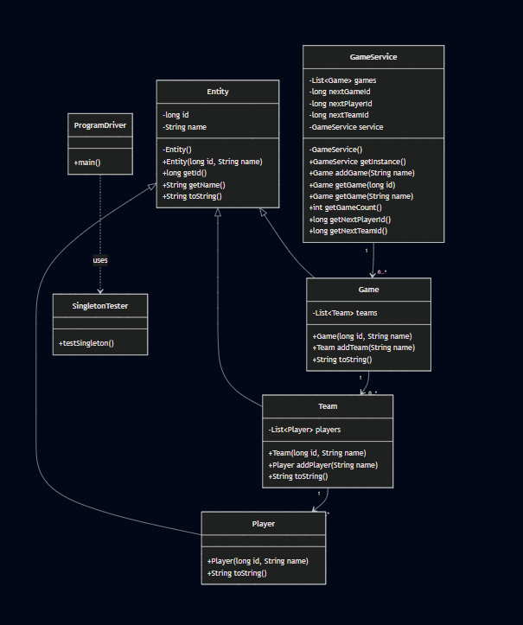



Evaluation (next page)

Development Requirements | Mac | Linux | Windows | Mobile Devices
Server Side | macOS provides a stable UNIX-based environment that can host Java web applications productively. However, Apple hardware is comparatively expensive and offers fewer deployment options than Linux in enterprise environments, making it less attractive for large-scale production servers. | Linux is the industry standard for hosting web applications due to its stability, security, low resource consumption, and open-source licensing. It integrates well with Java application servers and cloud platforms while providing spectacular scalability and uptime. | Windows Server offers strong enterprise support and familiar administration tools, but licensing costs and greater resource requirements make it less cost-effective than Linux for large-scale web deployments. | Mobile operating systems are designed as client platforms rather than application servers. Limited processing power, storage, and continuous network availability make them unsuitable for hosting a distributed web application.
Client Side | macOS users can access the application through modern web browsers without needing to own platform-specific software. Development costs are neutral since Java-based web applications remain largely platform independent. | Linux users can also access the application through standard web browsers. Although Linux has a smaller desktop market share, browser compatibility allows it to participate without additional development effort. | Windows supports virtually every major web browser and represents the largest desktop user base, making it an important client platform. Java's platform independence reduces the need for Windows-specific modifications. | Mobile devices represent a subliminal portion of modern users. Responsive web technologies allow smartphones and tablets to participate without having to reach out to separate Android and iOS applications, reducing long-term development costs.
Development Tools | Java, Eclipse, IntelliJ IDEA, Apache Tomcat, Git, Maven, and Gradle are all fully supported on macOS, providing a comprehensive software development environment. | Linux offers stellar support for Java development tools, open-source compilers, version control systems, build automation, and web servers. Its flexibility makes it fairly suitable for enterprise software development. | Windows provides full compatibility with Java development through Eclipse, IntelliJ IDEA, Visual Studio Code, Maven, Git, and Apache Tomcat. It remains one of the most commonly used development environments for Java applications. | Mobile clients primarily require standards-compliant web browsers rather than native development tools. Responsive HTML5, CSS, JavaScript, and modern browser support allow mobile devices to interact with the server regardless of operating system.

Recommendations

1. Operating Platform

Linux is the recommended operating platform for hosting Draw It or Lose It as a web-based application. Its stability, security, scalability, and open-source licensing make it well suited for enterprise deployment while admiringly reducing operational costs. Linux also dominates modern cloud hosting environments, making it an ideal platform for future expansion as the application's user base grows.

2. Operating Systems Architectures

Linux supports modern multi-user and multi-process architectures capable of impressively handling numerous simultaneous game sessions. Its support for multithreading enables multiple users to interact with the application concurrently without compromising performance. Combined with Java's platform-independent runtime environment, Linux provides a reliable and stable architecture capable of serving clients across Windows, macOS, Linux, and mobile operating systems.
3. Storage Management

A relational database management system such as PostgreSQL or MySQL is recommended for persistent and continuous storage of game data, player information, team assignments, and application records. These database systems provide transactional integrity, clear-cut indexing, backup capabilities, and scalability while integrating seamlessly with Java-based applications through standard database connectivity frameworks.

4. Memory Management

Java's automatic garbage collection simplifies memory management by reclaiming unused objects without all sorts of manual intervention, reducing the likelihood of memory leaks and improving application stability. Combined with the Singleton design pattern implemented within the GameService class, memory usage remains solid by ensuring that only one central service instance exists while shared resources are managed without mishaps throughout the application.

5. Distributed Systems and Networks

A distributed client-server architecture enables Draw It or Lose It to support users across multiple operating systems and features through a standard web browser. Clients communicate with the central application server over secure network protocols, allowing gameplay to remain synchronised regardless of the user's device. Designing the application as a distributed system also builds upon scalability, fault tolerance, and maintainability by centralising application logic while wholly separating it from client devices.

6. Security

Security should be implemented through multiple complementary measures as priority, including encrypted HTTPS communication, secure user authentication, familiar userbase, role-based authorisation, password hashing, and last of all, routine security updates. Sensitive information should be protected during transmission and while stored within the database as a start. Linux further strengthens the application's security through its well-built and reliable permission model, regular security patches, and mature server administration tools, overall helping protect both user data and application integrity.

